Polyphenol Oxidase Activity in Apples in Saline Solutions

# Introduction

Polyphenol oxidase is a copper containing enzyme present in many fruits. This protein is responsible for the enzymatic browning reaction that occurs when tissues are damaged during the handling, storage and processing of fresh fruits and vegetables, as well as some animal products (Aydin et al., 2015). When the fruit is damaged, the enzyme is released. In apples, polyphenol oxidase speeds up the reaction between oxygen and the mildly acidic compound, phenol, in the apple to create melanin. This reaction turns the apple brown after it has been cut or otherwise damaged.

Enzyme activity can be affected by many factors such as temperature, pH, moisture, and salinity. Increasing salinity will decrease melanin production in apples. Salinity was chosen as salt is known to effect enzyme activity. Small amounts of salt can increase enzyme activity but too much salt inhibits enzyme activity (Park and Raines, 2001).

If salt is an enzyme inhibitor, then the melanin production in the apple submerged in water (control solution, 0% salinity) will be greater than the melanin production in the highest salinity solution (10%). The melanin production in the apple slices in 1% salinity should be higher than the production in 10% salinity.

# Methods

One Macintosh apple was peeled and cut into 15 slices using a paring knife. The 15 slices were scored with a plastic fork to further damage the cells and promote release of the enzyme. Relative color (Figure 1) of the apple slices compared to the chart were recorded. Three slices of similar size were added to five 300mL plastic beakers labeled control, 1%, 2.5%, 5% and 10%. Approximately 100ml of saline solutions with 0% (control), 1%, 2.5%, 5%, and 10% salinity were added to their respective beakers, just enough to cover the apple slices. There are a total of four experimental treatments and one control with three replicates of each in each.

After 30 minutes of soaking, the slices were removed from the saline solution and relative color was recorded again. Slices were returned to the solutions. Color was measured every 30 minutes, a total of seven times (including the initial T=0) for a total of 180 minutes (T=180) in the saline solutions.

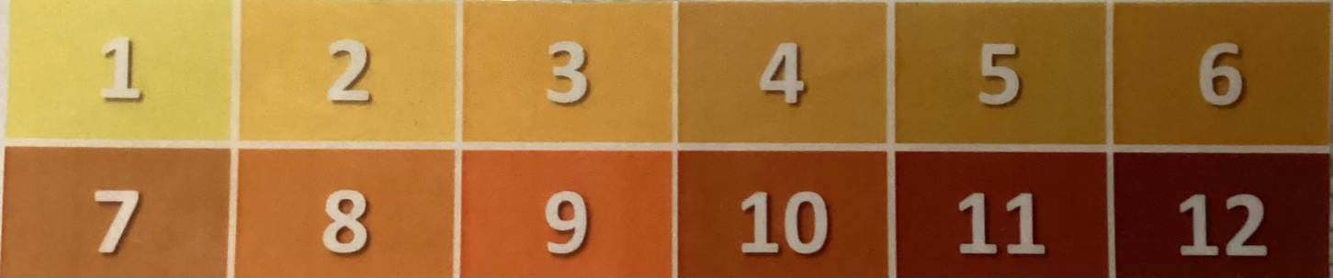

Figure 1 Color Score Value Chart**.** One is the lightest color score value and 12 is the darkest and reddest color score value. Color gets darker and redder as the color score increases. Unlisted values include 0, anything lighter than 1, and 13, anything darker than 12.

# Results

The apples in the control solution, water with no saline, browned faster and darker than any of the apples in saline solution. There was very little difference between the rate of browning in the 1%, 2.5%, and 5% saline solutions. The apples in the 10% saline solution had a slightly larger difference to the other saline solutions. All samples were within the range of 0-7 throughout the entire experiment. The control apple slices (0% salinity) had a max of seven. The apples in 1%, 2.5%, and 5% salinity all reached a max of two. The apples in 10% salinity reached a max of four at T=30 but by T=180 the max had decreased to three. The browning of the apples in the water increased from a range of 0-1 to 7. The browning of the apples in 1% saline solution increased from a range of 0-2 to a range of 1-2. The browning of the apples in 2.5% saline solutions increased from a range of 0-2 to a range of 1-2. The browning of apples in 5% saline solutions increased from a range of 0-1 to 2. The apples in 10% saline solution increased from a range of 0-2 to a range of 1-3.

Figure 2 Average Brownness of Apples in Saline Solutions Over Time. The apples in the control solution, water (0% salinity) reached an average of seven at T=150. The apples in the 1% saline solution reached a max average of 1.67 at T=30. The apples in 2.5% saline solution also reached a max average 1.67 at T=30. The apples in the 5% saline solution reached a max average of two at T=120. The error bars represent standard deviation for each set of three slices in each of the three experimental treatments and the control. Standard deviation ranges from 1.15 to 0.

# Conclusion

The presence of saline slowed the browning of the apples. The saline solutions inhibited the enzyme causing browning in apples. The hypothesis is not fully supported because the increased salinity did not decrease the browning of the apple. It is not completely rejected because the salinity did decrease browning from the control with no salinity. Increasing the amount of saline in the solution had little effect on the apple, all the experimental treatments slowed the browning of the apples.

This experiment was subject to human error because the brownness rating was done by opinion. The apples pieces floated at the top of the solutions from T=0 to T=30, the incomplete submersion allowed for browning of the apples in the saline solution. Varying sizes of apple pieces and changes in lighting also may have been sources of error during this experiment.

# References

Aydin, Bahar, Ilhami Gulcin and Saleh H. Alwasel. (2015) “Purification and Characterization of

Polyphenol Oxidase from Hemşin Apple (Malus Communis L.).” *International Journal of Food Properties*, *vol.* 18, no. 12, 2015, pp. 2735–45, <https://doi.org/10.1080/10942912.2015.1012725>.

Park, Chiwook, and Ronald T. Raines. (2001) “Quantitative Analysis of the Effect of Salt

Concentration on Enzymatic Catalysis.” *Journal of the American Chemical Society*, *vol*. 123, no. 46, Nov. 2001, pp. 11472–11479, <https://doi.org/10.1021/ja0164834>.